FIRST MAKE ADD THE LIBRARY OF MYSQL->

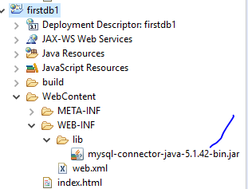

And build its path and add it into refrence libarary.



And setup the web.xml

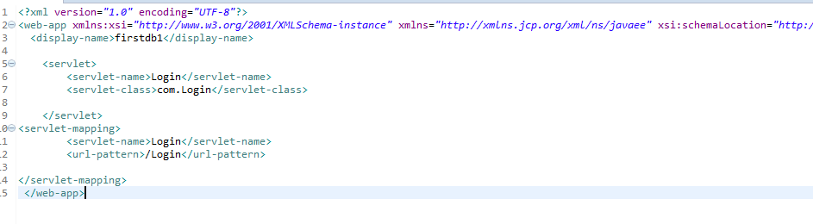

AND MAKE SERVLET LKE THIS;

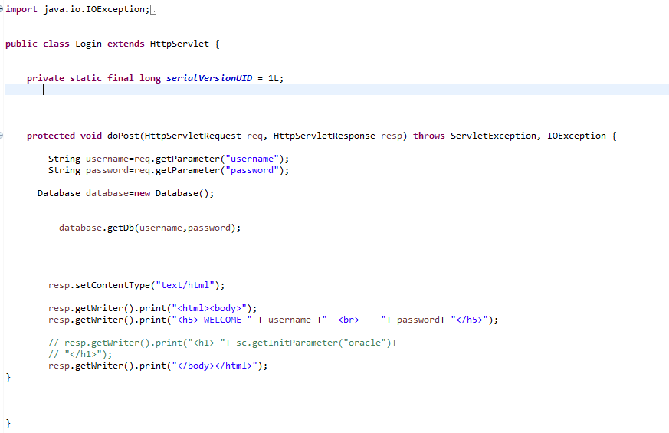

And this is a getDb function->

